**UNIT – II**

# FUNCTIONS-DESIGNING STRUCTURED PROGRAMS:

The planning for large programs consists of first understanding the problem as a whole, second breaking it into simpler, understandable parts. We call each of these parts of a program a **module** and the process of subdividing a problem into manageable parts **topdown design**.

The principles of top-down design and structured programming dictate that a program should be divided into a main module and its related modules. Each module is in turn divided into sub-modules until the resulting modules are intrinsic; that is, until they are implicitly understood without further division.

Top-down design is usually done using a visual representation of the modules known

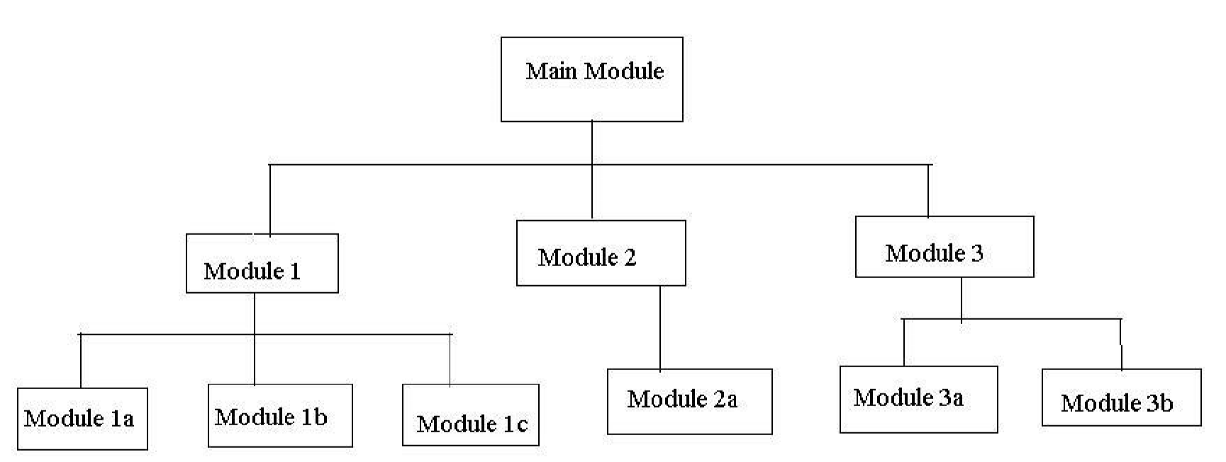

as a structure chart. The structure chart shows the relation between each module and its

sub

-

modules.

The structure chart is read top

-

down, left

-

right. First we read Main Module.

Main Module represents our entire se

t of code to solve the problem.

**Structure Chart**

Moving down and left, we then read Module 1. On the same level with Module 1 are Module 2 and Module 3. The Main Module consists of three sub-modules. At this level, however we are dealing only with Module 1. Module 1 is further subdivided into three modules, Module 1a, Module 1b, and Module 1c. To write the code for Module 1, we need to write code for its three sub-modules.

The Main Module is known as a calling module because it has sub-modules. Each of the sub-modules is known as a called module. But because Modules 1, 2, and 3 also have submodules, they are also calling modules; they are both called and calling modules.

Communication between modules in a structure chart is allowed only through a calling module. If Module 1 needs to send data to Module 2, the data must be passed through the calling module, Main Module. No communication can take place directly between modules that do not have a calling-called relationship.

How can Module 1a send data to Module 3b

It first sends data to Module 1, which in turn sends it to the Main Module, which passes it to Module 3, and then on to Module 3b.

The technique used to pass data to a function is known as parameter passing. The parameters are contained in a list that is a definition of the data passed to the function by the caller. The list serves as a formal declaration of the data types and names.

## FUNCTIONS :

A function is a self contained program segment that carries out some specific well defined tasks.

**Advantages of functions:**

1. Write your code as collections of small functions to make your program modular

2.Structured programming

3.Code easier to debug

4.Easier modification

5.Reusable in other programs

**Function Definition :**

type func_name( parameter list )

{

declarations;

statements;

}

**FUNCTION HEADER :**

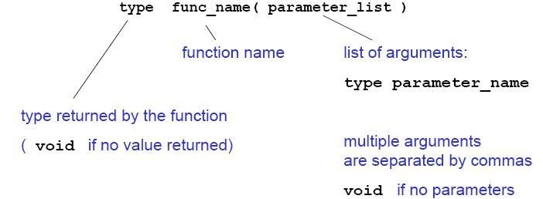

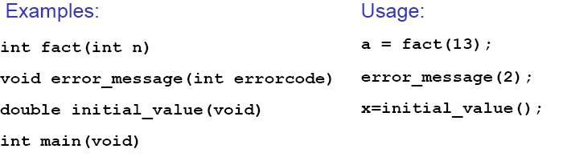

**FUNCTION PROTOTYPES**

If a function is not defined before it is used, it must be declared by specifying the return type and the types of the parameters.

**int sqrt(int );**

Tells the compiler that the function **sqrt()** takes an argument of type integer and returns a integer . These function prototypes are placed at the top of the program, or in a separate header file, **file.h**, included as

**#include "file.h"**

Variable names in the argument list of a function declaration are optional:

**void f (char, int);**

**void f (char c, int i); /*equivalent but makes code more readable */**

If all functions are defined before they are used, no prototypes are needed. In this case, **main()** is the last function of the program.

**SCOPE RULES FOR FUNCTIONS :**

Variables defined within a function (including main) are local to this function and no other function has direct access to them. The only way to pass variables to function is as parameters. The only way to pass (a single) variable back to the calling

function is via the return statement

**Ex:**

int func (int n)

{

printf(“%d\n”,b);

return n;

}//b not defined locally!

int main (void)

{

int a = 2, b = 1, c;

c = func(a);

return 0;

}

**FUNCTION CALLS :**

When a function is called, expressions in the parameter list are evaluated (in no particular order!) and results are transformed to the required type. Parameters are copied to local variables for the function and function body is executed when return is encountered, the function is terminated and the result (specified in the return statement) is passed to the calling function (for example main).

Ex:

int fact (int n)

{

int i, product = 1;

for (i = 2; i <= n; ++i)

product *= i;

return product;

}

int main (void)

{

int i = 12;

printf(“%d”,fact(i));

return 0;

}

## TYPES OF FUNCTIONS:

**USER DEFINED FUNCTIONS:**

Every program must have a main function to indicate where the program has to begin its execution. While it is possible to code any program utilizing only main function, it leads to a number of problems. The program may become too large and complex and as a result task of debugging, testing and maintaining becomes difficult.

If a program is divided into functional parts, then each part may be independently coded and later combined into a single unit, these subprograms called “functions” are much easier to understand debug and test.

The advantages of using functions are

1. It facilitates top-down modular programming.

1. The length of a source program can be reduced by using functions at appropriate places.
2. It is easy to locate and isolate a faculty function for further investigations.
3. A function may be used by many other programs.

A function is a self-contained block of code that performs a particular task.

The form of the C functions.

function-name ( argument list ) argument declaration;

{ local variable declarations; executable statement 1;

executabie statement 2;

----------

return (expression) ;

}

The return statement is the mechanism for returning a value to the calling function. All functions by default returns int type data. we can force a function to return a particular type of data by using a type specifier in the header.

***Note: A function can be called by simply using the function name in the statement.***

## STANDARD LIBRARY FUNCTIONS AND HEADER FILES:

C functions can be classified into two categories, **namely, library functions and user-defined functions** .Main is the example of user-defined functions. **Printf and scanf belong to the category of library functions**. The main difference between these two categories is that library functions are not required to be written by us where as a userdefined function has to be developed by the user at the time of writing a program. However, a user-defined function can later become a part of the c program library.

**MATH.H**

The math library contains functions for performing common mathematical operations.

Some of the functions are :

**cos :** returns the cosine of x, where x is in radians **exp:** returns "e" raised to a given power **pow :** returns a given number raised to another number **sin :** returns the sine of x, where x is in radians **sqrt :** returns the square root of x

**tan :** returns the tangent of x, where x is in radians

**ceil :** The ceiling function rounds a number with a decimal part up to the next highestinteger (written mathematically as x)

**floor :** The floor function rounds a number with a decimal part down to the next lowest

**STRING.H**

There are many functions for manipulating strings. Some of the more useful are: **strcat :** Concatenates (i.e., adds) two strings

**strcmp:** Compares two strings **strcpy:** Copies a string

**strlen:** Calculates the length of a string (not including the null) **strstr:** Finds a string within another string **strtok:** Divides a string into tokens (i.e., parts)

**STDIO.H**

**Printf:** Formatted printing to stdout

**Scanf:** Formatted input from stdin

**Getc:** Get a character from a stream (e.g, stdin or a file) **putc:** Write a character to a stream (e.g, stdout or a file) **fgets:** Get a string from a stream **fputs:** Write a string to a stream **fopen:** Open a file **fclose:** Close a file

**STDLIB.H**

**Atof:** Convert a string to a double (not a float)

**Atoi:** Convert a string to an int

**Exit:** Terminate a program, return an integer value **free:** Release allocated memory **malloc:** Allocate memory

## CATEGORIES OF FUNCTIONS:

A function depending on whether arguments are present or not and whether a value is returned or not may belong to.

1. Functions with no arguments and no return values.
2. Functions with arguments and no return values.
3. Functions with arguments and return values.

1. **Functions with no arguments and no return values :**

When a function has no arguments, it does not receive any data from calling function.

In effect, there is no data transfer between calling function and called function.

1. **Arguments but no return values :**

The function takes argument but does not return value.

The actual (sent through main) and formal(declared in header section) should match in number, type and order.

In case actual arguments are more than formal arguments, extra actual arguments are discarded. On other hand unmatched formal arguments are initialized to some garbage values.

**PARAMETER PASSING TECHNIQUES:**

Parameter passing mechanism in „C‟ is of two types.

* 1. Call by Value
  2. Call by Reference.

The process of passing the actual value of variables is known as Call by Value.

The process of calling a function using pointers to pass the addresses of variables is known as Call by Reference. The function which is called by reference can change the value of the variable used in the call.

**Example of Call by Value:**

#include <stdio.h> void swap(int,int); main()

{ int a,b;

printf(“Enter the Values of a and b:”); scanf(“%d%d”,&a,&b); printf(“Before Swapping \n”); printf(“a = %d \t b = %d”, a,b); swap(a,b); printf(“After Swapping \n”);

printf(“a = %d \t b = %d”, a,b);

}

void swap(int a, int b)

{

int temp; temp = a; a = b;

b = temp;

}

**Example of Call by Reference:**

#include<stdio.h>

main()

{ int a,b; a = 10; b = 20; swap (&a, &b); printf(“After Swapping \n”);

printf(“a = %d \t b = %d”, a,b);

}

void swap(int *x, int *y)

{

int temp; temp = *x; *x = *y;

*y = temp;

}

## STORAGE CLASSES :

In ‘C’ a variable can have any one of four Storage Classes.

1. Automatic Variables
2. External Variables
3. Static Variables
4. Register Variables

**AUTOMATIC VARIABLES :**

They are declared inside a function in which they are to be utilized.

They are created when function is called and destroyed automatically when the function is exited, hence the name automatic.

Automatic Variables are therefore **private (or local)** to the function in which they are declared. Because of this property, automatic variables are also referred to as local or internal variables.

**By default declaration is automatic**. One important feature of automatic variables is that their value cannot be changed accidentally by what happens in some other function in the program.

#include<stdio.h> main()

{

int m=1000; func2(); printf(“%d\n”,m);

}

func1()

{

int m=10;

printf(“%d\n”,m);

}

func2()

{

int m=100; func1();

printf(“%d”,m);

}

First, any variable local to main will normally live throughout the whole program, although it is active only in main.

Secondly, during recursion, nested variables are unique auto variables, a situation similar to function nested auto variables with identical names.

**EXTERNAL VARIABLES :**

Variables that are both alive and active throughout entire program are known as external variables. They are also known as Global Variables. In case a local and global have same name local variable will have precedence over global one in function where it is declared.

#include<stdio.h>

int x;

main()

{

x=10; printf(“%d”,x); printf(“x=%d”,fun1()); printf(“x=%d”,fun2()); printf(“x=%d”,fun3());

}

fun1()

{

x=x+10;

return(x);

}

fun2()

{

int x; x=1; return(x);

}

fun3()

{

x=x+10; return(x);

}

An extern within a function provides the type information to just that one function.

**STATIC VARIABLES :**

The value of Static Variable persists until the end of program. A variable can be declared Static using Keyword Static like Internal & External Static Variables are differentiated depending whether they are declared inside or outside of auto variables, except that they remain alive throughout the remainder of program.

#include<stdio.h> main()

{

int I;

for (I=1;I<=3;I++)

stat();

} stat()

{ static int x=0; x=x+1; printf(“x=%d\n”,x);

}

**REGISTER VARIABLES :**

We can tell the Compiler that a variable should be kept in one of the machines registers, instead of keeping in the memory. Since a register access is much faster than a memory access, keeping frequently accessed variables in register will lead to faster execution

Syntax:

register int Count.

## RECURSIVE FUNCTIONS:

**Recursion is a repetitive process in which a function calls itself** (or) A function is called recursive if it calls itself either directly or indirectly. In C, all functions can be used recursively.

**Example: Fibonacci Numbers**

A recursive function for Fibonacci numbers (0,1,1,2,3,5,8,13...)

**/* Function with recursion*/**

int fibonacci(int n)

{ if (n <= 1) return n; else

return (fibonacci(n-1) + fibonacci(n-2));

}

With recursion 1.4 x 10 9 function calls needed to find the 43rd Fibonacci number(which has the value 433494437) .If possible, it is better to write iterative functions.

int factorial (int n) **/* iterative version */**

{ for ( ; n > 1; --n) product *= n;

return product;

}

# ARRAYS :

***An array is a group of related data items that share a common name.***

Ex:- Students

The complete set of students are represented using an array name students. A particular value is indicated by writing a number called index number or subscript in brackets after array name. The complete set of value is referred to as an array, the individual values are called elements.

## ONE – DIMENSIONAL ARRAYS :

A list of items can be given one variable index is called single subscripted variable or a one-dimensional array.

The subscript value starts from 0. If we want 5 elements the declaration will be

int number[5];

|  |  |  |  |  |
| --- | --- | --- | --- | --- |
| 88 | 89 | 87 | 99 | 92 |

The elements will be number[0], number[1], number[2], number[3], number[4]

There will not be number[5]

Ex: int marks[5]={88,89,87,99,92}

0 1 2 3 4 index

**Declaration of One - Dimensional Arrays :**

Type variable – name [sizes];

Type – data type of all elements Ex: int, float etc.,

Variable – name – is an identifier

Size – is the maximum no of elements that can be stored.

Ex:- float avg[50]

This array is of type float. Its name is avg. and it can contains 50 elements only. The range starting from 0 – 49 elements.

**Initialization of Arrays :**

Initialization of elements of arrays can be done in same way as ordinary variables are done when they are declared.

Type array name[size] = {List of Value};

Ex:- int number[3]={0,0,0};

If the number of values in the list is less than number of elements then only that elements will be initialized. The remaining elements will be set to zero automatically.

Ex:- float total[5]= {0.0,15.75,-10};

The size may be omitted. In such cases, Compiler allocates enough space for all initialized elements.

int counter[ ]= {1,1,1,1};

## TWO – DIMENSIONAL ARRAYS:

To store tables we need two dimensional arrays. Each table consists of rows and columns. Two dimensional arrays are declare as

type array name [row-size][col-size];

**INITIALIZING TWO DIMENSIONAL ARRAYS:**

They can be initialized by following their declaration with a list of initial values enclosed in braces.

Ex:- int table[2][3] = {0,0,0,1,1,1};

Initializes the elements of first row to zero and second row to one. The initialization is done by row by row. The above statement can be written as

int table[2][3] = {{0,0,0},{1,1,1}};

When all elements are to be initialized to zero, following short-cut method may be used.

int m[3][5] = {{0},{0},{0}};